General Salon & Appointment Information

All appointments must be pre-booked either over the telephone (tel 07889 744348) or via online booking at www.novyhealthandbeauty.co.uk

24 hours before your appointment you need to complete and return a Health Screening Questionnaire. You can download the form here

If you are unwell, please let me know, so we can rearrange your appointment for when you feel better. Please note if less than 24 hours’ notice is given for a cancellation a charge may be made inline with the salon’s cancellation policy.

Please arrive at the time of your appointment and ring the doorbell so I know you have arrived. Then I will come to meet you.

Please do not bring any food into the salon. You may wish to bring a drink of water with you for after your treatment.

You contact information is always held safe and secure and in accordance with GDPR, however it may be necessary to share your personal contact information with NHS Track & Trace.

I have always followed the strictest sanitation and sterilisation guidelines in the salon, so a lot of what has been published as guidelines since the start of the pandemic is nothing new. That been said, I do want to let you know what I do on a regular basis to keep us all safe!

I always leave a gap in between clients to allow time for changing of towels, cleaning surfaces and equipment.
In preparation for your appointment all surfaces, tools and equipment are cleaned and sterilised. Fresh towels are put out for use during your treatment. I continue to wear a mask and/or visor during your treatments and ask that where possible you wear a mask. Hand sanitiser is available when you come into the salon for your use.

I appreciate your support and want to reassure you that I will err or the side of caution and never take our safety for granted. If you have any questions, please just ask.

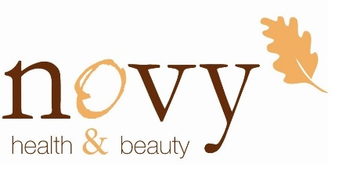
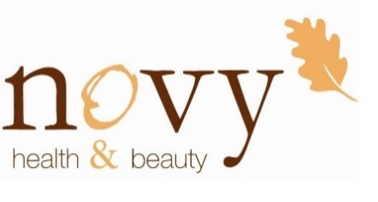
Joanne

